**Task 2 - Video Game Sales Dataset Analysis**

The provided video game sales dataset contains information about games, including their ranking, name, platform, year of release, genre, publisher, and sales data for North America, Europe, Japan, and other regions. Here are the insights obtained from the dataset:

1. More games are released for the **PS2 controller**

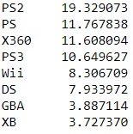

1. The Most games are in the genre of **Sports ,Action followed by platform games** . Platform games are like running ,jumping games like super Mario.

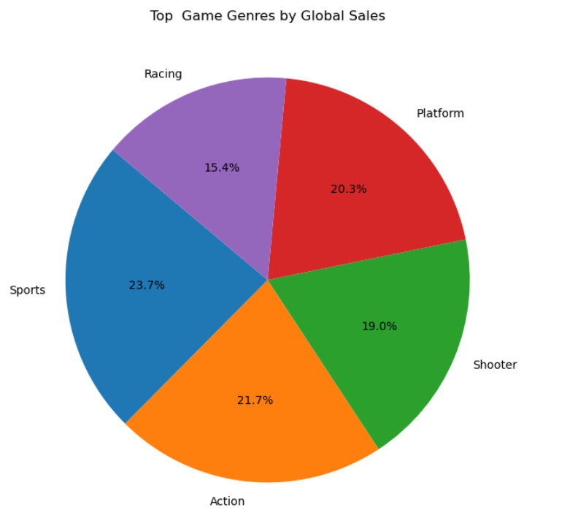

1. From the Dataset I can know that the **sales of the Video games is Drastically increases after 2000**

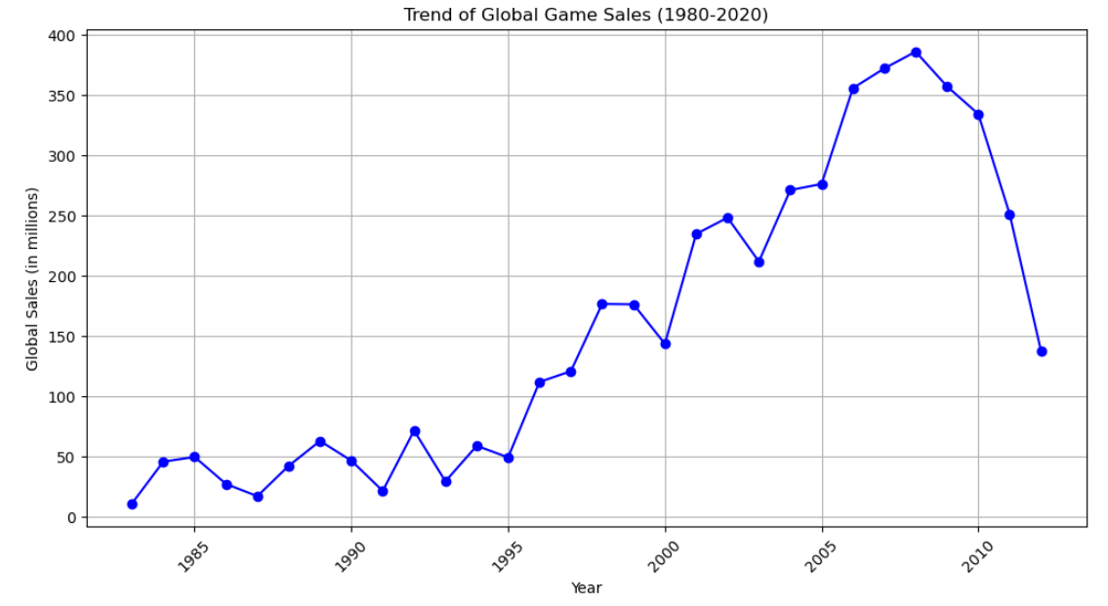

1. The Average sales in North America is almost 2 times of 2nd highest Average sales Europe

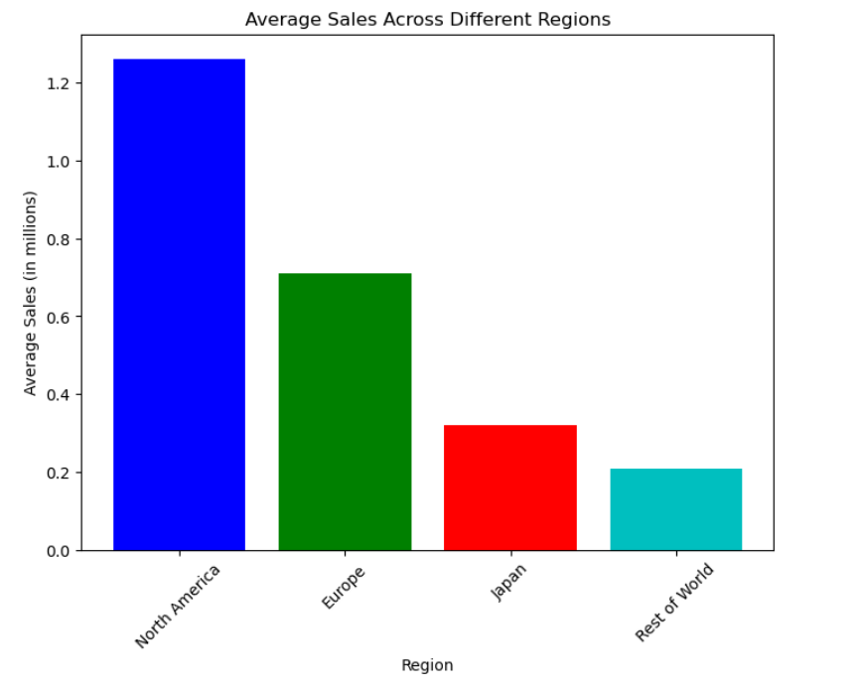

1. The Nintendo have the global sales around 1400 million which is also the times the sales of 2nd highest Electronic arts which around 700 millions

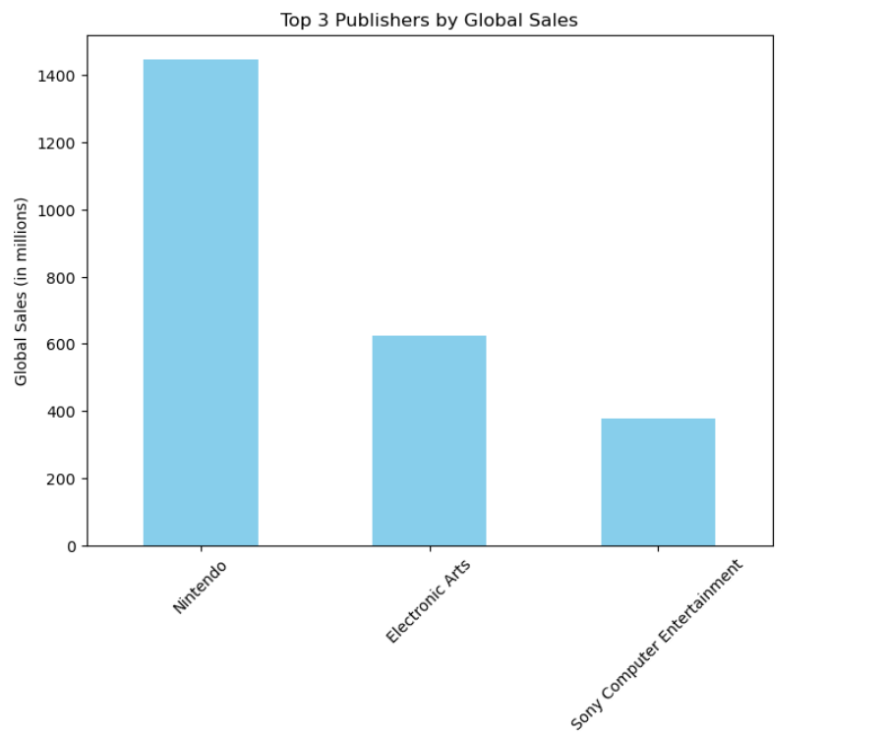

1. Top 5 revenue games in each region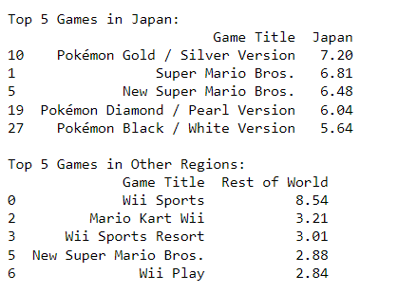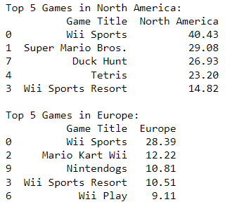:

**The Other thing I learnt from this dataset is Video game industry is very huge with lot if projects.**